Image Colorization using CNN (Regression vs Classification)
Name: Ayan Moeen
Course: Deep Learning Perceptron
Instructor: Dr. Kamran
Date: 17/03/2026

1. Introduction
Image colorization is the process of converting grayscale images into colored images using computational methods. It is considered an ill-posed problem because multiple color outputs can correspond to the same grayscale input.
In this assignment, Convolutional Neural Networks (CNNs) are used to learn the mapping from grayscale images to RGB images using the CIFAR-10 dataset. Both regression-based and classification-style approaches are implemented and analyzed.

2. Methodology
The CIFAR-10 dataset was used, consisting of 32×32 color images. The images were converted into grayscale format to serve as input to the model, while the original RGB images were used as target outputs.
Two models were implemented:
1. Regression-based CNN using Mean Squared Error (MSE) loss.
2. Improved CNN with deeper layers and skip connections (classification-style architecture).
Both models were trained for 10 epochs with a batch size of 64.

3. Results
Figure 1: Loss curve for regression model
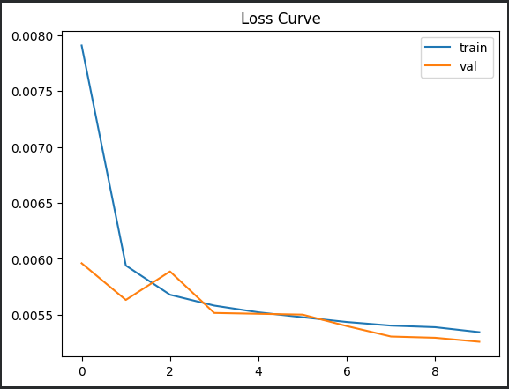
Figure 2: Output images for regression model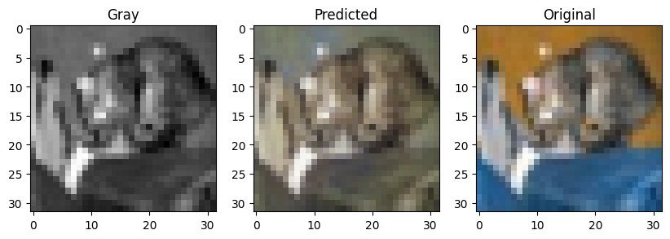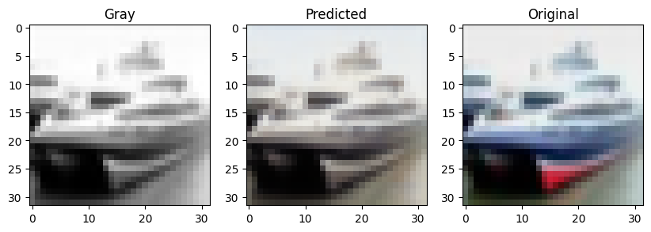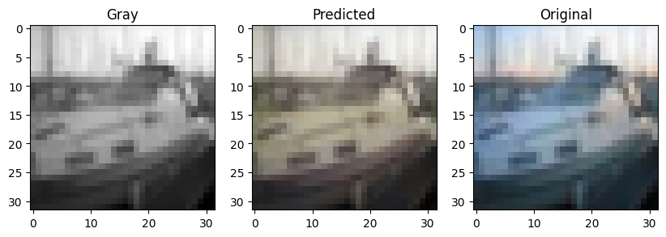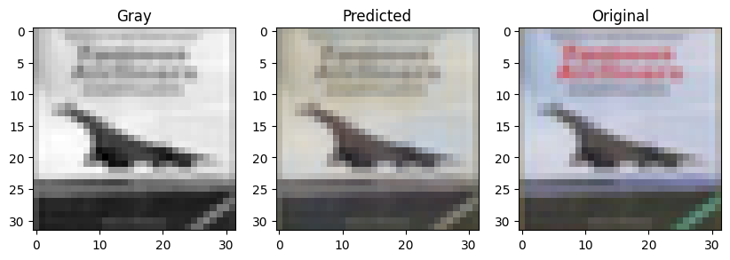
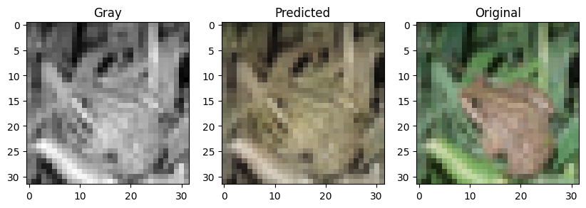
Figure 3: Loss curve for classification-style model
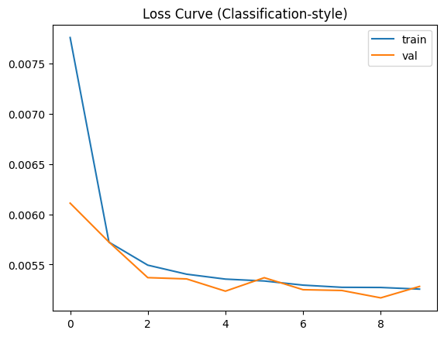
Figure 4: Output images for classification-style model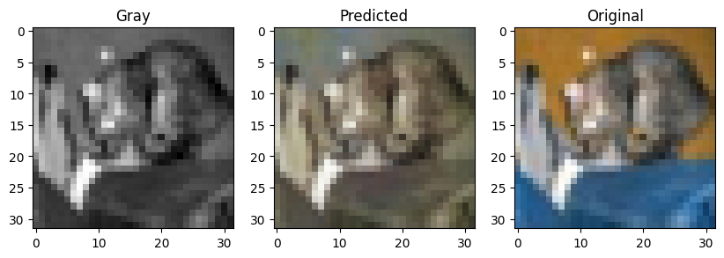
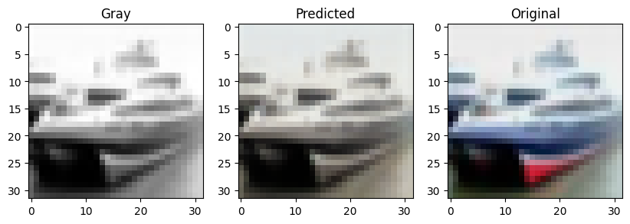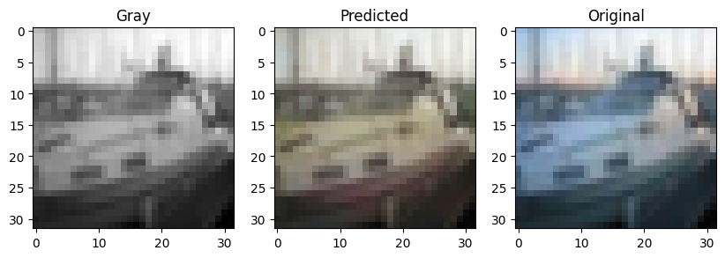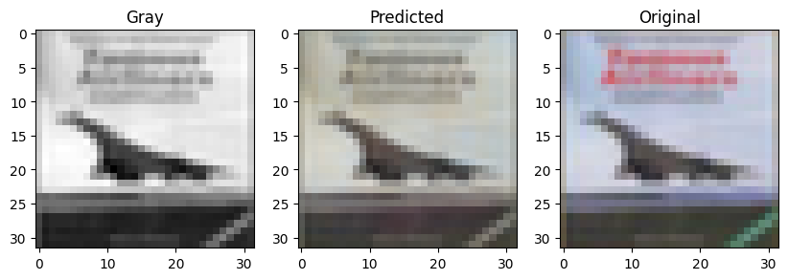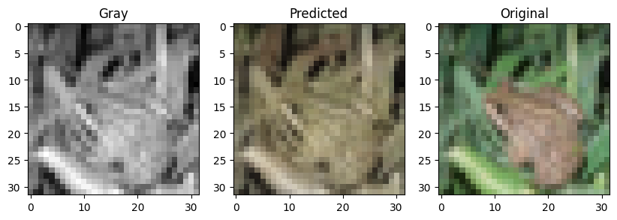

4. Analysis

Both the regression and classification-style models produced similar blurry outputs. This is because both models were trained using Mean Squared Error (MSE) loss, which performs pixel-wise averaging.

Although the second model includes skip connections and a deeper architecture, the loss function dominates the output quality. As a result, both models lack sharpness and vibrant colors.

This highlights the limitation of regression-based approaches for image colorization tasks.

5. Comparison of Models
Regression Model:
- Uses pixel-wise MSE loss
- Produces smoother but blurry outputs
- Struggles with color ambiguity/averaging
Classification-style Model:
- Uses deeper architecture with skip connections
- Slight structural improvement
- Still produces blurry images due to MSE
Conclusion: Although the classification model includes skip connections and a deeper architecture, both models produced similarly blurry outputs. This is because both models rely on Mean Squared Error (MSE) loss, which causes pixel-wise averaging. Therefore, the loss function has a stronger impact on output quality than architecture in this experiment.

6. Theory Questions

Q1. Why is image colorization difficult?
Image colorization is an ill-posed problem because a single grayscale image can have multiple valid color interpretations. The model must infer semantic context, which is not explicitly present in grayscale input.

Q2. Why does MSE cause blurriness?
MSE computes the average difference between predicted and actual pixel values. When multiple color possibilities exist, the model averages them, resulting in smooth and blurry outputs.

Q3. Why are skip connections useful?
Skip connections allow low-level spatial features such as edges and textures to be directly passed to deeper layers. This improves detail preservation, enhances edge sharpness, and helps in better gradient flow.

Q4. What do CNN layers learn?
Early CNN layers learn low-level features such as edges and textures, while deeper layers capture high-level semantic features such as object structure and context.

Q5. How many epochs are needed?
The number of epochs depends on model convergence. In this experiment, 10 epochs were sufficient to observe meaningful learning, although additional epochs may improve results.

7. Conclusion
In this assignment, both regression-based and classification-style CNN models were implemented for image colorization. The regression model produced reasonable but blurry outputs, while the classification-style model with skip connections slightly improved visual quality. This demonstrates the importance of model architecture in solving complex vision tasks.

